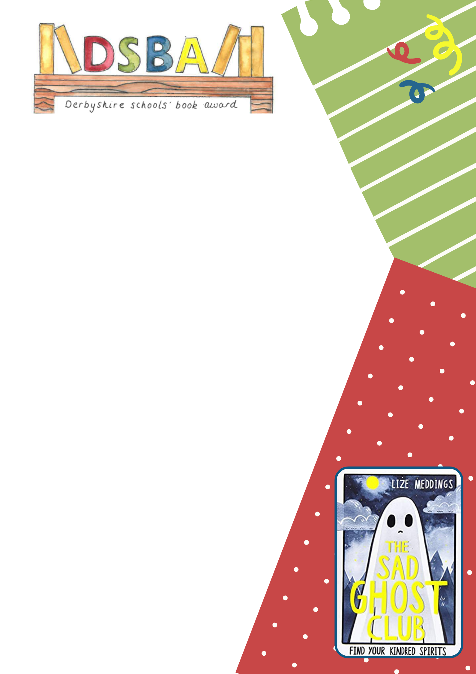


Decorate the bookmark with how the ghost feels at the end when they find kindred spirits and feel part of their own club.

Make it look bright & colourful and full of positivity!

Handy tip: to make it last longer ask your Librarian or group leader if they can laminate it for you.
