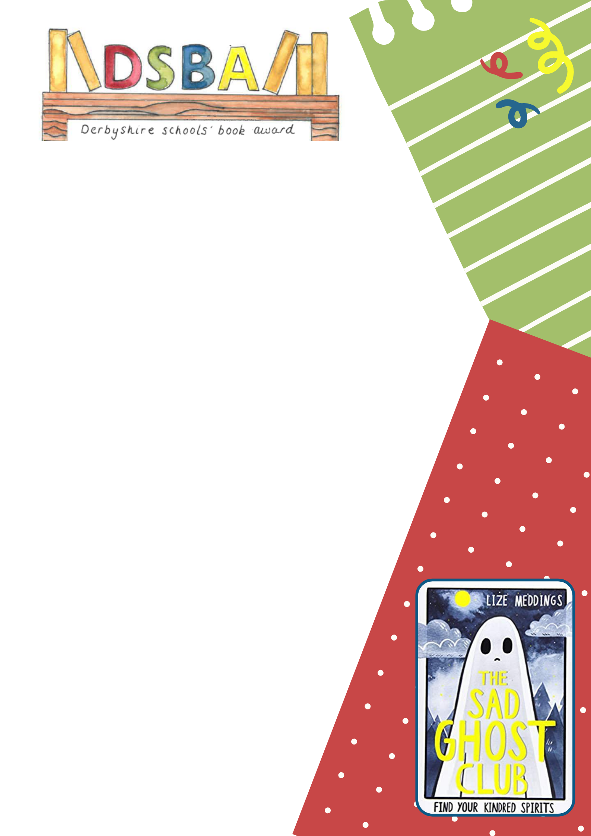
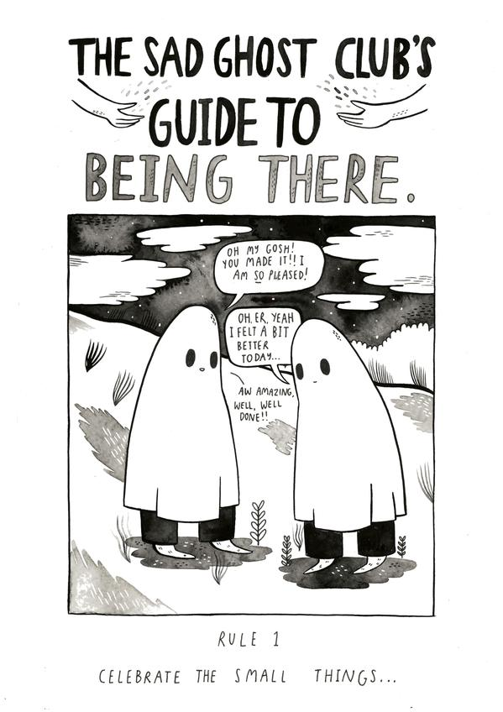

Think of the themes of the story to help you:
Finding friends
Secret society
Social anxiety
Belonging

